Name: _______________________

/36

**Year 8 Earth & Beyond Test 2012**

**Multiple choice** 10 marks

|  |  |
| --- | --- |
| Question Number | Answer |
| **1** |  |
| **2** |  |
| **3** |  |
| **4** |  |
| **5** |  |
| **6** |  |
| **7** |  |
| **8** |  |
| **9** |  |
| **10** |  |

1. Bauxite is refined to produce aluminium. Bauxite is a:

1. Mineral
2. Ore
3. Rock
4. Element

2. Basalt is formed when lava cools. What type of rock is it?

1. Intrusive Igneous Rock
2. Extrusive Igneous Rock
3. Metamorphic
4. Sedimentary

3. Magma and lava

1. Are both types of rock
2. Are both minerals
3. Are both forms of molten rock
4. Are exactly the same thing

4. Marble is a rock that is commonly used as a bench top as it is very hard and not porous. Which type of rock is marble?

1. Intrusive Igneous Rock
2. Extrusive Igneous Rock
3. Metamorphic
4. Sedimentary

5. Humus is:

1. The organisms living in soil
2. A type of rock
3. The decayed remains of dead organisms
4. The result of chemical weathering

6. Water entering cracks in the rock then expanding when the temperature goes below 0oC is an example of

1. Erosion
2. Physical Weathering
3. Chemical Weathering
4. Sedimentation

7. Particles being deposited at the bottom of a stream is an example of

1. Erosion
2. Physical Weathering
3. Weathering
4. Sedimentation

8. A piece of rock was caught in ice at the beginning of winter. As spring came and the ice thawed the piece of rock travelled down the hill with the melting ice. This is an example of:

1. Erosion
2. Physical Weathering
3. Chemical Weathering
4. Sedimentation

9. What most commonly leads to the formation of metamorphic rocks?

1. Erosion
2. Weathering
3. Movement of tectonic plates
4. Volcanic eruptions

10. Rocks are:

1. Made mostly of organic materials
2. Made mostly of quartz and basalt
3. Made mostly of one or more minerals
4. Made mostly of fossils

Match the following terms with their definitions by writing the appropriate number in each box

9 marks

Soil Structure 1. A living thing

Soil Texture 2. The ability to support plant growth

Consistency 3. The rate at which water will enter and pass through a soil

Permeability 4. How well the soil particles join to form lumps

Fertility 5. Pockets of air or water within soil or rock

Horizon 6. The tendency of soil particles to stick together

Humus 7. Layers found in soil

Organism 8. The decayed remains of living organisms

Pore spaces 9. The size of the particles that make up the soil

There are 4 components to most soils. List them: 2 marks

* ___________________________________________________________________________
* ___________________________________________________________________________
* ___________________________________________________________________________
* ___________________________________________________________________________

Explain the difference between physical and chemical weathering. 2 marks

________________________________________________________________________________________________________________________________________________________________________________________________________________________________________________________________________________________________________________________________________

Limestone is made of shells and skeletons of marine creatures, coal is formed from dead plant material. Why are they both classified as Sedimentary rocks? 1 mark

________________________________________________________________________________________________________________________________________________________________________________________________________________________________________________________________________________________________________________________________________

Which type of rock is shown below? Explain your choice. 2 marks

________________________________________________________________________________________________________________________________________________________________________________________________________________________________________________________________________________________________________________________________________

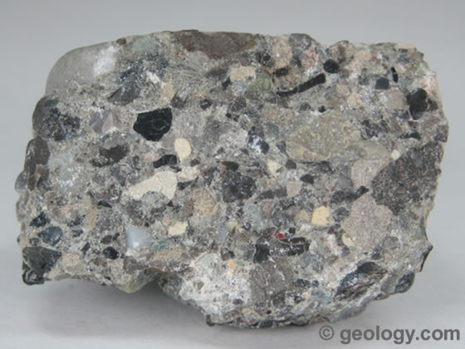

Granite is an igneous rock with large crystals in it. What type of igneous rock is granite, explain your choice. 2 marks

________________________________________________________________________________________________________________________________________________________________________________________________________________________________________________________________________________________________________________________________________

8 marks

